Using Vim and C toolchain

Using Vim and the C toolchain usually means:
- Edit code with Vim.
- Compile with GCC or Clang.
- Run & debug the resulting program.
- Automate builds with make.

Creating a file in C, compiling using gcc and clang and running it
Objective
Learn how to edit, compile, run, and manage C programs using Vim, GCC/Clang, and Makefiles.

Install Vim if it is not already installed.
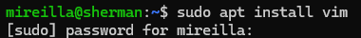
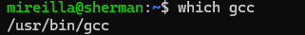
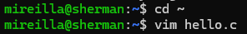

This is the content of the file hello.c:
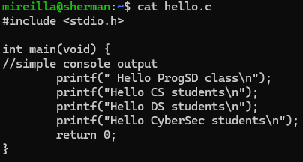
Compile first and run the program.
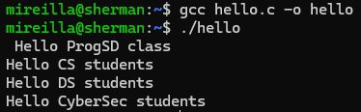
The same could be accomplished using just one line (compile and run in one step).
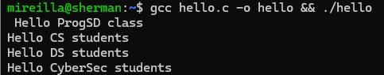
gcc hello.c -o hello compile the program.
&& only run the next command if the first one succeeds.
./hello run the newly compiled program.

If you do not want to keep the hello executable at all, you can compile, run, and delete the executable afterwards. It means the executable is not saved.
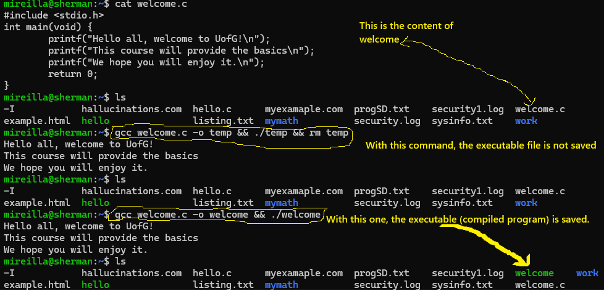

Clang is a modern, open-source C, C++, and Objective-C compiler. It does the same job as gcc (the GNU Compiler Collection), that is, turning the C source code into machine code you can run.
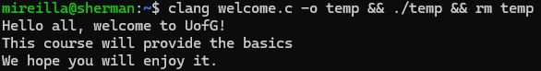

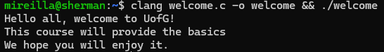

Makefile
Creating a file called Makefile:
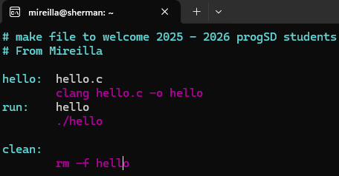
Then I will use make run to run it and make clean to delete the executable file.
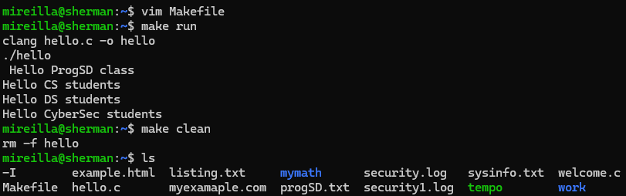

Example 2
In this example, I included the command to extract the IP addresses from security1.log file.
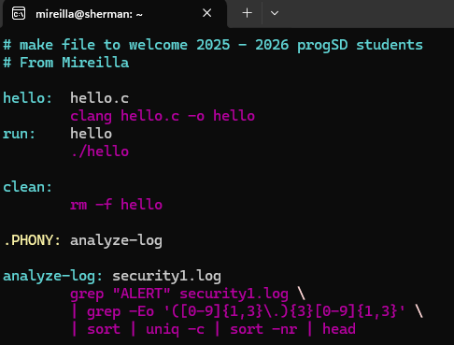

The output when I run it.
